Ms. Eberle’s Scholar Survival Guide
Everything you need to know for science class…

You are a science scholar. This means that our science class runs in a certain way. We go outside, we research, we do experiments, we work in teams, we celebrate and recognize each other’s growth, and we push ourselves to always grow. It isn’t always easy to be a science scholar…but that’s ok! We will all make mistakes and fail during the year...but that is all part of being a scientist and a scholar.

Name: ________________________________
Signed: _______________ Date: ___________
How scholars act in our class…
Supplies: Each day in class, you will always need to have the following:
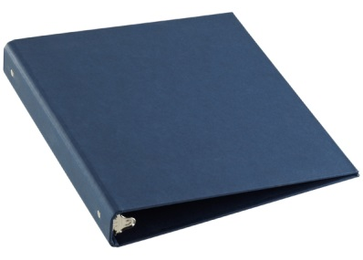
- Your science binder with loose leaf paper
- Sharp pencils
- Your science textbook (if the sign is up on the wall)
- Your homework

Website: Our class website’s address is www.bw13.weebly.com. The website lists:
- Copies of homework, projects, class notes, and other papers
- Our class calendar and important dates
- Updates from classmates and Ms. Eberle about the things we are learning. If you are absent, you can always check the site to see what you missed

Ms. Eberle’s Non-Negotiables:
- You must have permission before getting out of your seat.
- Be kind – leave classmates and the classroom better off than how you found it.
- Take care of personal needs (hair, etc) before or after class – they don’t go well with science!

SLANT and Tracking the Speaker:
- SLANT is a way to remember what “active listening position” looks like. We will practice this in class many times this fall.
- Tracking the speaker:
  - Just like when you are in college or working at a job, it is important to make eye contact and face the person you are speaking with. This makes you look confident and the person you are speaking with feels like you are respectful and trustworthy.
  - Before anyone answers a question or Ms. Eberle will give directions, 100% of the class needs to track the speaker.

Quizzes and Tests:
You will have a quiz once a week (usually Fridays) to check our mastery of the week’s goals. You will always have a study guide for every test. Quiz and test dates will always be listed on our class calendar and on our science website.

Voice Level:
- Level zeroThis is the voice scholars use for independent work. Voices are silent, scholars are working alone and raise their hand before speaking.
- Level oneThis is the voice scholars use for partner work. This is a 12 inch voice. Your partner should be able to hear you, but not other tables.
- Level two This is the voice scholars use to answer questions or share comments in class. Everyone should be able to hear clearly. This is a strong, professional voice.
- Level three This is the voice level scholars use to celebrate other scholars’ great thinking. Example— shout outs, award days…

Attention Getting Signals:
- While Ms. Eberle may use others too... our main attention getter is: Ms. Eberle says, “M-I-Z.” Scholars say, “Z-O-U.”
- Pencils and other materials are put down, voices are level 0, eyes are tracking Ms. Eberle, and scholars are holding still. This should happen in 5 seconds or less.

Heading: Always label your papers with the MIZZOU heading on the top right. If you forget, you have a sheet in your binder.
Name
Date
Day of the Week
Period
Beginning of class:
- Line up against the lockers. Ms. Eberle will give you permission to enter the classroom. If you are not in your seat or following Ms. Eberle’s instructions when the bell rings, you are considered tardy.
- Once in your seat, take out your binder, book, and completed homework.
- Open up to your D.N.A. section of your binder. Follow the D.N.A, (do now activity), instructions and complete the assignment on voice level zero.
- If you need to take care of pencil sharpening, make up work, or other needs, you must have permission from Ms. Eberle. If you have a class job that involves something at the beginning of class, follow your job rules.

Dismissal:
- Scholars will wait for dismissal from Ms. Eberle, not the bell.
- Classrooms that are not 100% on voice level zero will not be dismissed.
- Scholars are to walk on the right side of the hall.
- If need to use the restroom, use the restroom closest to your next class.

Restrooms and the Nurse:
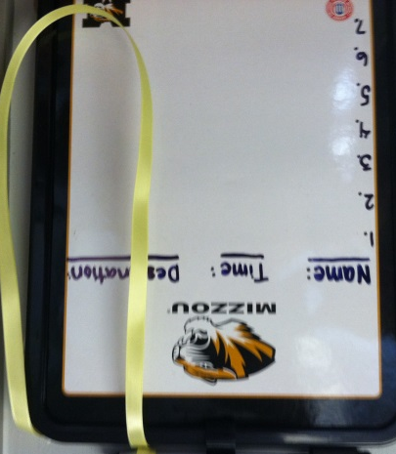
- You will receive two emergency bathroom passes each 9 weeks. Please plan to use the restroom before or after class. Unless you are throwing up, bleeding, need to take medicine brought from home, or have a fever, I will only write nurse passes for the end of class.
- When you leave the room, you need a pass or signed planner. Once you have those two things, sign out on the white board by the door.
Trash:
- If you accumulate trash during class, please put trash on the corner of you table. When you are dismissed from class, bring it with you and put it in the trashcan.
- If you are sick and have tissues or need the trashcan / dustpan, raise your hand and let Ms. Eberle know.

Jobs:
- This is not just Ms. Eberle’s classroom – it is all of ours. There are many jobs scholars are in charge of leading. Jobs will change every 2 -3 weeks so everyone will get many chances.
- If your grade drops below a C or you receive a buddy room or higher consequence, you will be put on probation for one week. If you improve your grade or behavior, you will return to work. Substitutes will take over the jobs of scholars on probation.
- In exchange for your extra effort, you will be paid in Eagle bucks and points for your class team.

Binder and Table of Contents:
- You are responsible for keeping your D.N.A (do nows), class notes, and homework in your binder. We will set these up together at the beginning of the year.
- You will have a Table of Contents sheet for your binder. On the board, you can always double check that your table of contents and classwork are organized correctly.
- Ms. Eberle will grade your binder each month to give you credit for your do nows, organization, and notes. If you lose your binder, you will only receive a 50%. Keep your binder safe!
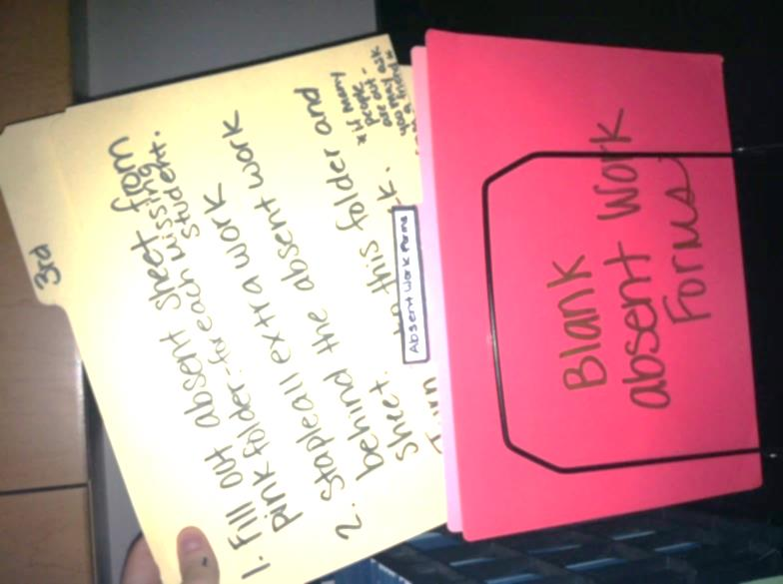
Make Up Work:
- “Major Make-Up Work”, a class job, will make a packet with the classwork and homework you missed that day. They will put the packet in the folder for your class period.
- When you return to class, you need to get the packet. If you missed notes, ask a friend to share their note page so you can keep your binder up-to-date. “I was absent” is not an excuse when binders are graded.

